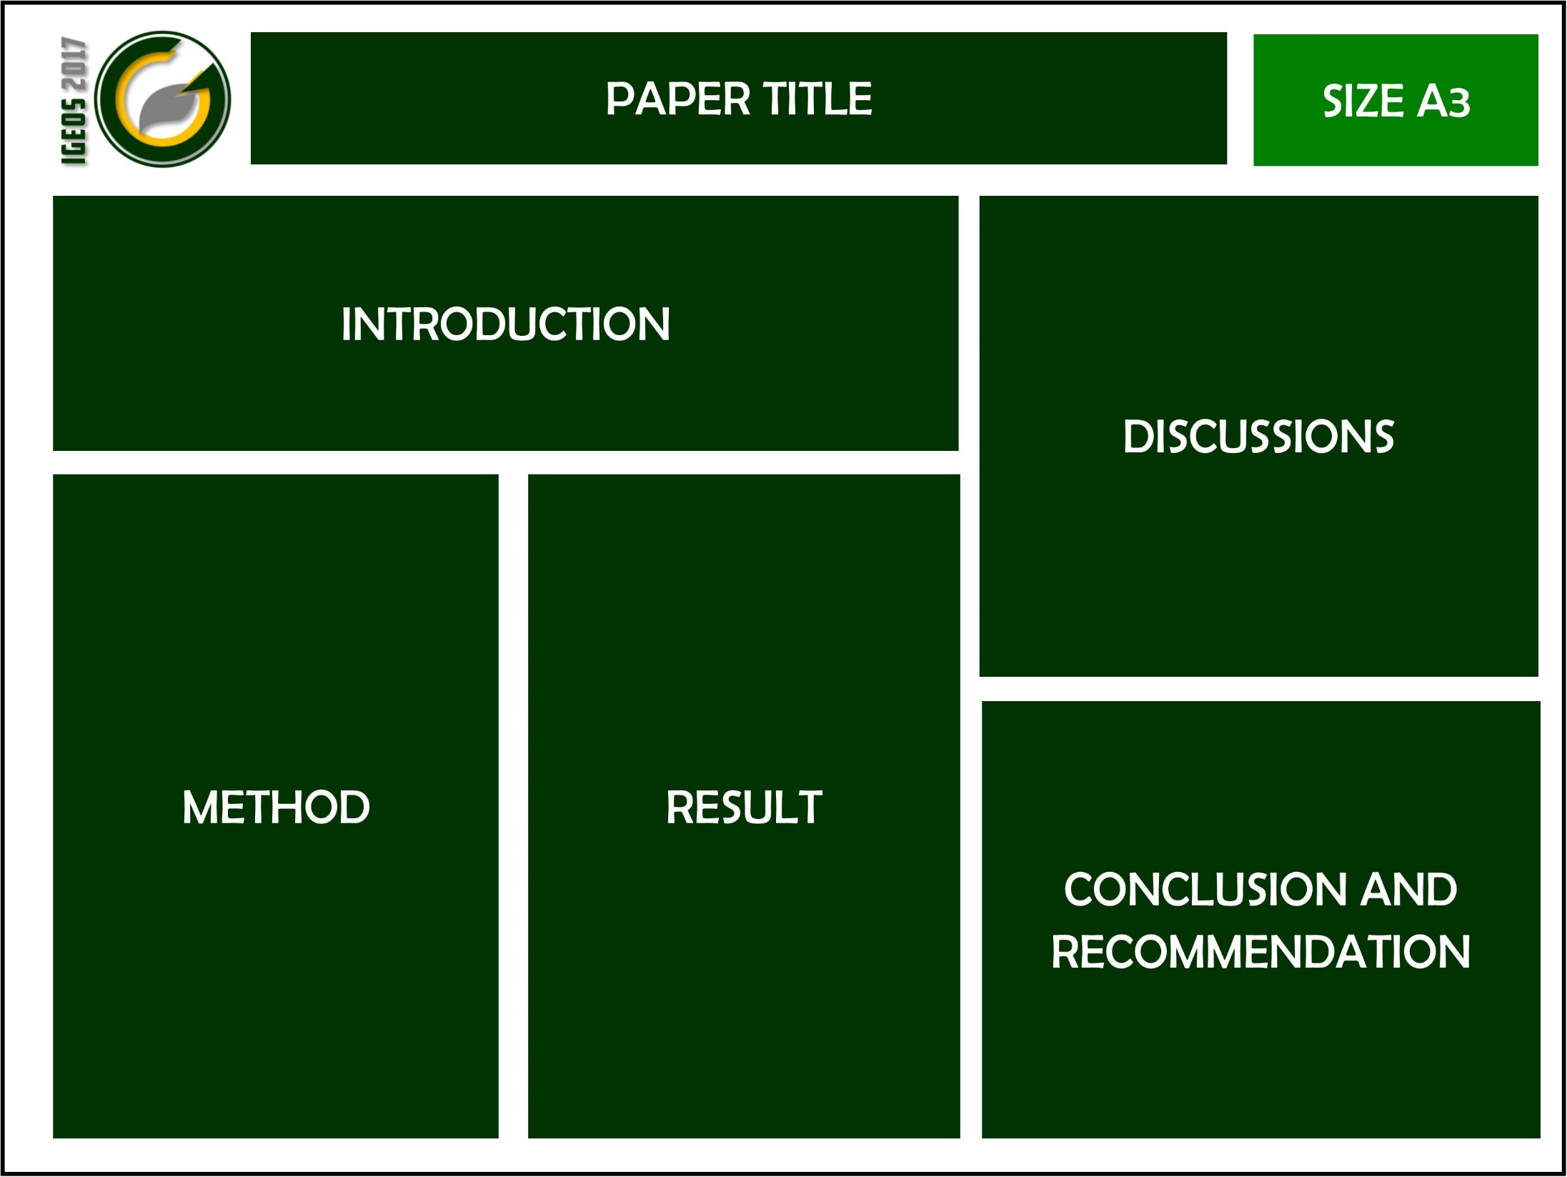

download link for IGEOS logo

http://igeos.conference.upi.edu/wp-content/uploads/2017/07/Logo-IGEOS.jpg